3. DESIGN FOR FLUCTUATING LOADING
FLUCTUATING LOADING: When the variation of load w. r. t. time is sinusoidal then the dynamic loading is said to be fluctuating loading.
$P_{max}=$Maximum Load | $P_{min}=$Minimum Load
$P_{mean}=$Mean Load$={\left(P_{max}+P_{min}\right)}/2$ | $P_{amp}=$Amplitude Load$={\left(P_{max}-P_{min}\right)}/2$

$σ_{max}=$Maximum Stress ($+ve or -ve or 0$) | $σ_{mean}=$Mean Stress$={\left(σ_{max}+σ_{min}\right)}/2$($+ve or -ve or 0$)
$σ_{min}=$Minimum Stress ($+ve or -ve or 0$) | $σ_{amp}=$Amplitude Stress$={\left(σ_{max}-σ_{min}\right)}/2$($+ve or 0$)

$$AMPLITUDE RATIO: A=\frac{σ_{amp}}{σ_{mean}}=\frac{1-R}{1+R}$$ | $$STRESS RATIO: R=\frac{σ_{min}}{σ_{max}}$$

TYPES OF FLUCTUATING LOAD
REPEATED LOADING | REVERSED LOADING
$$σ_{max} or σ_{min}=0⇔\left|σ_{mean}\right|=σ_{amp}$$ | $$σ_{mean}=0$$
Design is based on maximum load. | Experimental Results are used for design.
FATIGUE LOADING: It’s the weakening of component due to reversal of loading or cyclic loading. And material fails suddenly (Ductile and brittle both).
RR MOORE’S /ROTATING BEAM EXPERIMENTAL ANALYSIS
Specimen: Mild Steel  - Free from defects.  - No sudden reduction in cross section.  - Mirror Finished Surface.  Radius: 3.5in to 10in (88.9 mm to 254 mm)  Min. Dia.: 0.3in (7.62 mm)  Max. Dia.: 0.481in (12.217 mm)  Total Length: 3.4375in (87.312 mm) | 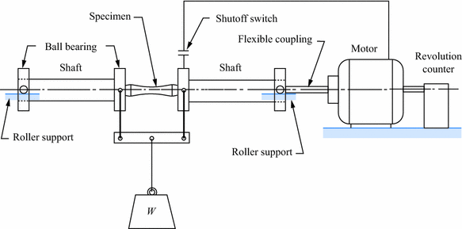
- Specimen is simply supported beam. And subjected to reversed pure bending (As shown in fig.).
S N DIAGRAM: $log N Vs log σ_{f} Graph$
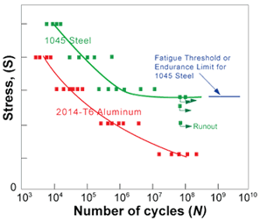 | 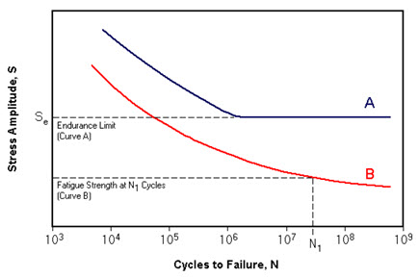
For aluminium, there is no endurance limit region where as mild steel has endurance limit region.
ENDURANCE LIMIT: It’s the point of loading at which the component starts experiencing fatigue due to cyclic loading. | ENDURANCE STRENGTH: It’s maximum amplitude stress that the standard specimen can withstand for a minimum of 10⁶ cycle when subjected to completely reversed loading without fatigue.
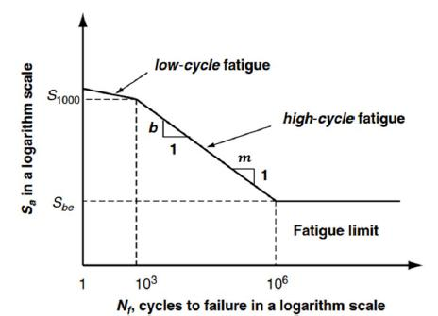 | For Steel,  $$For N={10}^{3}, σ_{e}^{'}=0.5σ_{ut}$$ $$For N={10}^{6}, σ_{e}^{'}=0.9σ_{ut}$$  For Iron, For Al, Cu,  $$σ_{e}^{'}=0.4σ_{ut}$$ $$σ_{e}^{'}=0.4σ_{ut}$$  Maximum life $N=5*{10}^{8}$
IMP POINTS RELATED TO STANDARD SPECIMEN USED IN EXPERIMENT:
- Min. diameter $d_{min}≈8 mm$.  - Surface of the specimen is polished to mirror finishing.  - No sudden reduction in cross section.  - Experiment is conducted at room temperature. | - Loading is pure bending.  - Specimen may or may not fail at endurance limit.  - The failure stress corresponding to ${10}^{6}$ cycles is endurance strength $σ_{e}^{'}$.
ACTUAL COMPONENT USED IN THE MACHINE:
$$σ_{e}=K_{a}K_{b}K_{c}K_{d}K_{e}\frac{1}{K_{f}}σ_{e}^{'}$$ | $σ_{e}=$ Corrected Endurance Strength.

SURFACE FINISHED FACTOR ($K_{a}$) |  | SIZE FACTOR $\left(K_{b}\right)$
Shrigley Equation, $K_{a}=A σ_{ut}^{B}$  $A,B$ Find using experiments. | If $K_{a}>1$,use $K_{a}=1$  For cast iron $K_{a}=1$ | $$K_{b}=1, for d≤8 mm$$  Shrigley and Mitchel equation;  $$K_{b}=1.189d^{-0.097}, For 8 mm<d≤250mm$$  $$K_{b}=0.6, For d>250mm$$

LOAD FACTOR ($K_{c}$) | RELIABILITY FACTOR ($K_{d}$)
For reversed Bending, $K_{c}=1$  For reversed axial loading, $K_{c}=0.7$  For reversed torsional loading, $K_{c}=0.577$  $[ ∵$From distortion energy theory, $τ_{e}^{'}={σ_{e}^{'}}/{\sqrt{3}}$ ] | % Success Reliability  50% $$K_{d}=1$$  90% $$K_{d}=0.897$$  99% $$K_{d}=0.814$$  99.9% $$K_{d}=0.759$$  99.9999% $$K_{d}=0.620$$
TEMPERATURE FACTOR ($K_{e}$)
$$K_{e}=1$$ | $$T≤450 °C$$
Shrigley and Mitchel equation;  $$K_{e}=1-0.0058[T-450]$$ | $$450 °C<T≤550 °C$$

Shrigley and Mitchel equation;
Can’t use for Cu, Mg, Al, Etc…
STRESS CONCENTRATION:
$$σ_{0}=\frac{F}{\left(w-d\right)t}$$ $$σ_{SC}>σ_{0}$$ $σ_{SC}$ depends material, reduction rate, Dimensions of cut.  Gradual reduction of Cross section induces less stress concentration. And sudden reduction causes high stress concentration. | $a=$ Length of semi major axis,  $b=$ Length of semi minor axis [Longitudinal],  $σ_{0}=$ Normal Stress/ Stress at minimum cross section,  $σ_{SC}=$ Maximum stress at minimum cross section due to stress concentration,
STRESS CONCENTRATION FACTOR ($K_{t}$):  It’s maximum concentration factor for a given component and shape of cut. | $$σ_{SC}=Kσ_{0}$$  “$K$” depends on dimension of cut, material.
$${\left(σ_{SC}\right)}_{max}=K_{t}σ_{0},{\left(σ_{SC}\right)}_{max} is maximum ∀ material$$  $K_{t}$ depends on shape of cut and it’s not dependent on material. | $$K_{t}=1+2\frac{lateral Length of Cut}{Longitudinal Length of Cut}\left(\frac{d}{w}≈0\right)$$

FATIGUE/ ACTUAL STRESS CONCENTRATION FACTOR $\left(K_{f}\right)$
For given material, maximum stress due to change in cross section at minimum cross section due to stress concentration given by, |  | $$σ_{SC}=K_{f}σ_{0}$$
Failure condition in actual, | $$σ_{0}={σ_{SC}}/{K_{f}}$$ | $$σ_{e}={σ_{e}^{'}}/{K_{f}}$$
$$K_{f}=\frac{Endurance Strength of Std. (or Notch free) Specimen }{Corrected (or Notch Specimen) Endurance Strength}$$
NOTCH SENSITIVITY$(q)$: It’s sensitivity of material toward cuts or notches.
$$q=\frac{∆σ_{act}}{∆σ_{th}}=\frac{σ_{SC}-σ_{0}}{{\left(σ_{SC}\right)}_{max}-σ_{0}}=\frac{σ_{0}\left[K_{f}-1\right]}{σ_{0}\left[K_{t}-1\right]}$$ | $$∴K_{f}=1+q\left[K_{t}-1\right]$$  $$0<q<1, hence 1<K_{f}<K_{t}$$ | $$K_{t}=1+2\frac{a}{b}$$
For circular Cut, $K_{t}=3$.
METHODS TO REDUCE STRESS CONCENTRATION: Stress concentration is localization of stress due to reduction in cross section. We can reduce stress concentration by Gradually reducing cross section,
Providing fillet radius | Providing Small Holes/ Notches near to vicinity region of the sudden reducing cross section
IMPORTANT POINT:
If $K_{t}$ and $q$ are given, find $K_{f}$ | If $K_{t}$ and $q$ are not given, $K_{f}=1$ | If $K_{t}$ given but $q$ is not given, $K_{f}=K_{t}$
INFINITE LIFE: For reversed loading, life of component $N>{10}^{6} cycles.$
$$To avoid fatigue(life of component N>{10}^{6} cycles): \frac{F_{a}}{A_{min}}=\frac{M_{a}}{Z_{min}}=\frac{σ_{e}}{FOS}$$
FINITE LIFE: For reversed loading, life of component ${10}^{3}<N<{10}^{6} cycles.$
At ${10}^{3} cycles$, $σ_{f}=σ_{m}=0.9 σ_{ut}$ | At ${10}^{6} cycles$, $σ_{f}=σ_{e}$
$$σ=A N^{B}(Valid for {10}^{3}<N<{10}^{6} cycles and reversed loading)$$

$$\sum{\frac{N_{i}}{L_{i}}}=1$$ | Fatigue Stress $$σ_{1}$$ $$σ_{2}$$ $$σ_{3}$$ $$…$$  Life Span (in time) before fatigue $$L_{1}$$ $$L_{2}$$ $$L_{3}$$ $$…$$  No of Revolution Actually Spend (in cycles) $$N_{1}$$ $$N_{2}$$ $$N_{3}$$ $$…$$

SODERBERG THEORY | GOODMAN THEORY
$$\frac{σ_{m}}{σ_{yt}}+\frac{σ_{a}}{σ_{e}}=\frac{1}{FOS}$$ | $$\frac{σ_{m}}{σ_{ut}}+\frac{σ_{a}}{σ_{e}}=\frac{1}{FOS}$$
GERBER THEORY (Parabolic Curve) | ASME THEORY (Elliptical Curve)
$${FOS}^{2}{\left(\frac{σ_{m}}{σ_{ut}}\right)}^{2}+FOS\frac{σ_{a}}{σ_{e}}=1$$ | $${\left(\frac{σ_{m}}{σ_{ut}}\right)}^{2}+{\left(\frac{σ_{a}}{σ_{e}}\right)}^{2}={\left(\frac{1}{FOS}\right)}^{2}$$
LANGER THEORY | MODIFIED GOODMAN THEORY
$${FOS}_{1}\frac{σ_{m}}{σ_{yt}}+{FOS}_{2}\frac{σ_{a}}{σ_{yt}}=1$$ | $$Slope =\frac{σ_{a}}{σ_{m}}≥\frac{y}{x}$$ | $$Slope =\frac{σ_{a}}{σ_{m}}≤\frac{y}{x}$$
 | Use Goodman Theory | Use Langer Theory
 | $y,x$ are intersection point of Langer’s line and Goodman line
COMBINED FLUCTUATING LOADING:
- Use Theory of failures to find $σ_{a} \& σ_{m}$.  Here all mean and amplitude loads will be given for combined loading condition.  - Use the theory of fluctuating loading. Find required parameters. | $$σ_{x}=σ_{x min} to σ_{x max}$$  $$σ_{y}=σ_{y min} to σ_{y max}$$  $$τ_{xy}=τ_{xy min} to τ_{xy max}$$

